

### AMAZON (Only For Engg)

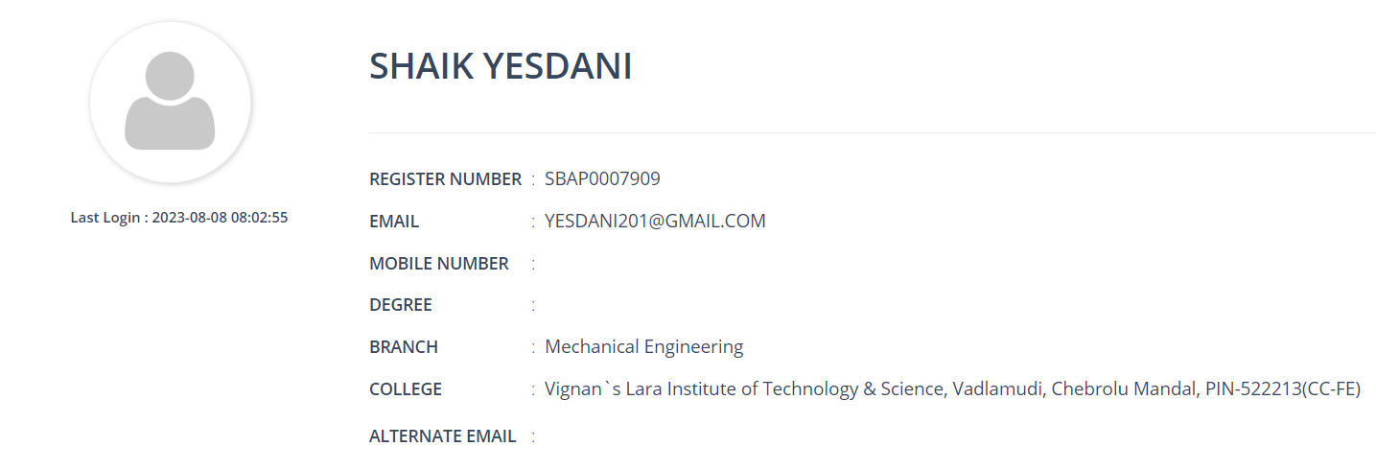

**AMAZON USER STORY:**

As a registered user,

I want to log in with my email id and password so that the system can authenticate me and I can trust it.

Acceptance Criteria,

• Ensure registered users and logged out.

• Ensure as a new user able to login with correct credentials.

If I go to the login page and enter my email with an incorrect password and click on Log in, then log in fails to login.

**Index**

**1. Introduction ………………………………………………………………………………………………………………..3**

**2. Purpose ……………………………………………………………………………………………………………………….3**

**3. Scope………………………………………………………………………………………………………………………….. 3**

**4. Test Cases …………………………………………………………………………………………………………………...4**

**Test Cases**

|  |  |
| --- | --- |
| **Test Case ID** | TC001 |
| **Test Scenario** | Check if the User can sign up successfully. |
| **Test Steps** | Go to the website  Click on the sign in  Click on create your amazon account  Fill all the necessary fields  Click on create your amazon account Test Data |

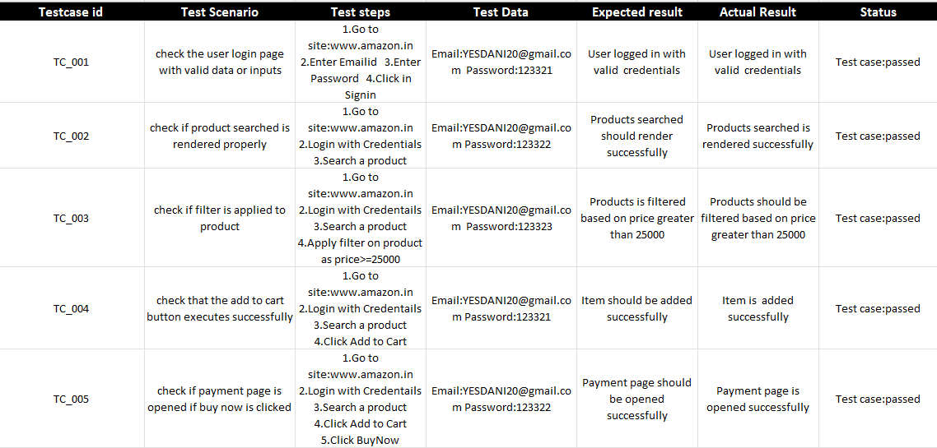

|  |  |
| --- | --- |
| **Test Case ID** | TC6 |
| **Test Scenario** | Check after adding any product to the cart, cart window will pop up or not |
| **Test Steps** | • Go to the website  • Open any product  • Add it to the cart  • Click on cart |
| **Test Data** | Same as test steps |
| **Expected Result** | Cart window should be popped up |
| **Actual Result** | As expected |
| **Pass/Fail** | Pass |

|  |  |
| --- | --- |
| **Test Case ID** | TC7 |
| **Test Scenario** | Check if the user can find the particular section of products from all products. |
| **Test Steps** | • Go to the website  • Click on all  • Click on electronics  • Click on headphones |
| **Test Data** | Same as test steps |
| **Expected Result** | Headphone products window should be opened |
| **Actual Result** | As expected |
| **Pass/Fail** | Pass |

|  |  |
| --- | --- |
| **Test Case ID** | TC-8 |
| **Test Scenario** | Check Search Engine with valid data. |
| **Test Steps** | * Go to <https://www.amazon.com> * Enter data on search bar. * Click on search button. |
| **Test Data** | Samsung headphone |
| **Expected Result** | List of Samsung Headphone |
| **Actual Result** | List of Samsung Headphone |
| **Pass/Fail** | pass |

|  |  |
| --- | --- |
| **Test Case ID** | TC-9 |
| **Test Scenario** | Check Search Engine with valid data. |
| **Test Steps** | * Go to <https://www.amazon.com> * Enter data on search bar. * Click on search button. |
| **Test Data** | “dbnqewuibf7t8f2tgrff8fg” |
| **Expected Result** | “Try checking your spelling or use more general terms” |
| **Actual Result** | “Try checking your spelling or use more general terms” |
| **Pass/Fail** | pass |

|  |  |
| --- | --- |
| **Test Case ID** | TC -10 |
| **Test Scenario** | Short item according to there price |
| **Test Steps** | * Go to <https://www.amazon.com> * Select Short list. * Select option from list by passing the image |
| **Test Data** | C:\Users\pawan\eclipse-workspace\amazonTestCase\assets\price.PNG |
| **Expected Result** | Lowest price item appear first |
| **Actual Result** | Lowest price item appear first |
| **Pass/Fail** | Pass |

|  |  |
| --- | --- |
| **Test Case ID** | TC -11 |
| **Test Scenario** | Select the element with Image scanning |
| **Test Steps** | * Go to <https://www.amazon.com> * Pass the Image of element need to be selected |
| **Test Data** | C:\Users\pawan\eclipse-workspace\amazonTestCase\assets\gift.PNG |
| **Expected Result** | C:\Users\pawan\eclipse-workspace\amazonTestCase\assets\actualResult.PNG |
| **Actual Result** | C:\Users\pawan\eclipse-workspace\amazonTestCase\assets\actualResult.PNG |
| **Pass/Fail** | Pass |

|  |  |
| --- | --- |
| **Test Case ID** | TC -12 |
| **Test Scenario** | Select the element with Image scanning |
| **Test Steps** | * Go to <https://www.amazon.com> * Pass the Image of element need to be selected |
| **Test Data** | C:\Users\pawan\eclipse-workspace\amazonTestCase\assets\jbl.PNG |
| **Expected Result** | C:\Users\pawan\eclipse-workspace\amazonTestCase\assets\jblExpected.PNG |
| **Actual Result** | C:\Users\pawan\eclipse-workspace\amazonTestCase\assets\orderReturn.PNG |
| **Pass/Fail** | Fail |